To use CPLEX inside Visual Studio, we need to adapt some project settings

Right click on the project (here: “Case2TOO2018”) and click on properties:

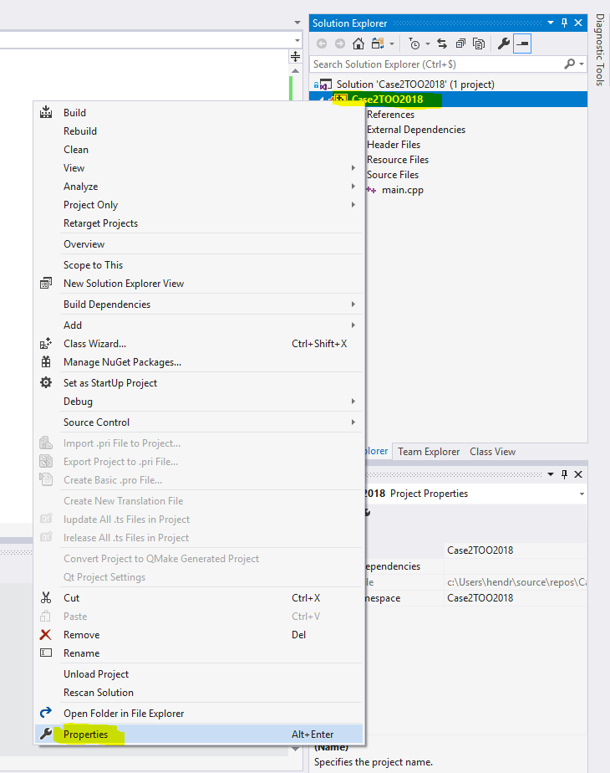

(1) Click on C/C++ in the left pane and go to Additional Include Directories

Click on the arrow and then click on edit:

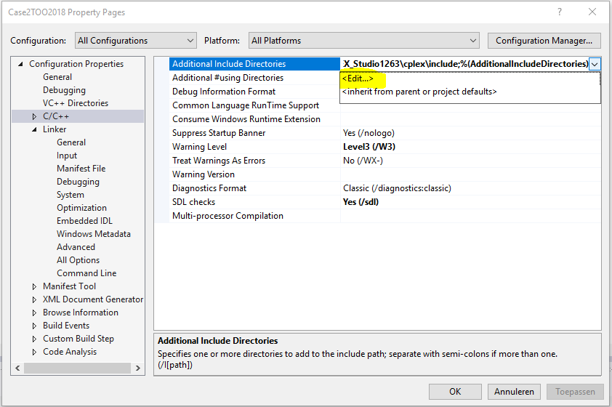

Add the path of the CPLEX “include” folder and click on OK

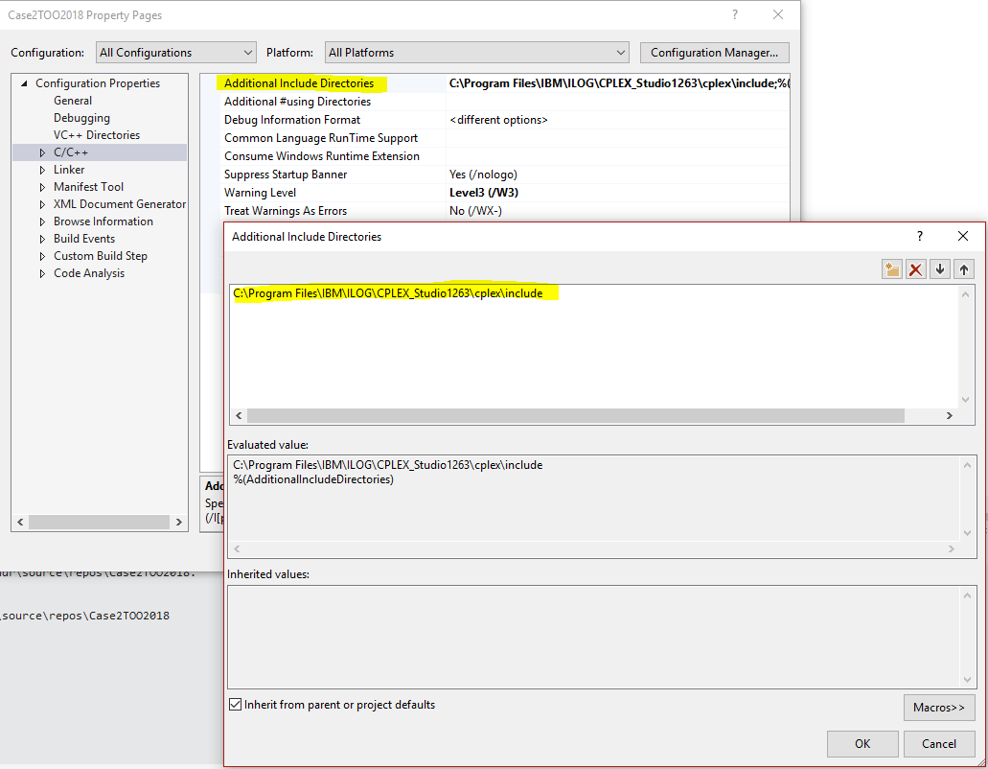

(2) Go to “linker” in the left pane. In “Additional Library Directories” add the folder \cplex\lib\x64_windows_vs2013\stat_mda

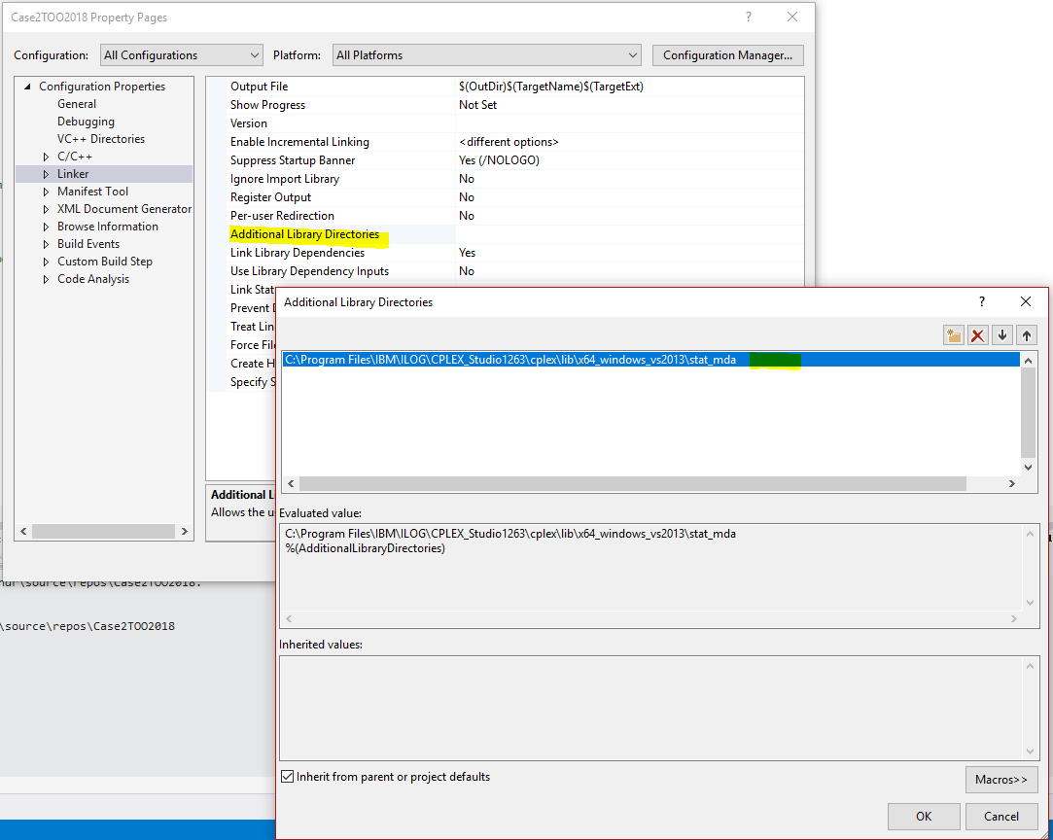

(3) Click on “input” in the left pane. In “Additional dependencies” add “cplex1263.lib”, where 12.6.3 refers to the version of CPLEX that you have installed. Check the name of the lib file to see which version you have.

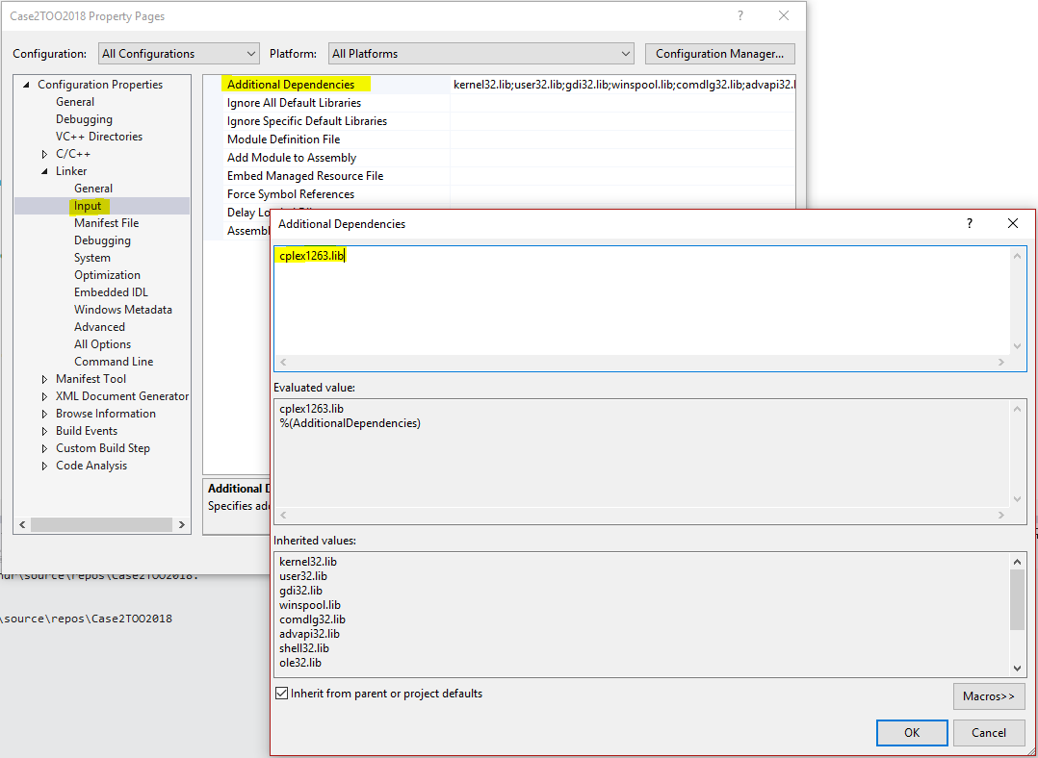

Done.